 |  | Page: | 1 (2)

The Image of Sweden in the US and Canada 2017

Summary

Background
The Swedish Institute (SI) is a government agency that promotes interest and confidence in Sweden around the world. SI seeks to establish cooperation and lasting relations with other countries through strategic communication and exchange in the fields of culture, education, science and business.
Key to this process is the understanding of Sweden’s shifting image in different demographics across the world. As part of an ongoing analysis of these dynamics, the SI conducts studies in order to understand what the general public in other countries know about Sweden and how they perceive the country.
This is the first study SI has conducted on the image of Sweden in the US and Canada. It focuses on the following questions:
1. How is Sweden perceived in the US and in Canada? Does age, gender, region and education level play a role in how Sweden is perceived?
2. Have the media coverage of Sweden had an impact on the image of Sweden in the US and Canada?
3. Has the image of Sweden changed and, if so, among which demographics?
4. What issues do the people in the US and Canada associate Sweden with?
An important part of the study concerns the development of a new narrative of Sweden and Swedish society. Migration issues are at the heart of this new narrative that is predominantly marked by violence and societal disturbances. Misleading and sometimes incorrect images of Sweden have been increasingly circulated in North American media reports and social media discussions following the refugee crisis of 2015. This study seeks to determine whether the frequently one-sided or biased reporting on Sweden and Swedish migration policy has had any effect on how the general public in the US and Canada perceives Sweden.

Methodology
The study was carried out in May–October 2017. The survey company Netigate/CINT provided web panels in the respective countries. Those who replied to the questionnaire numbered 3,278 in the US and 2,709 in Canada. The selection of respondents was representative in terms of sex, age and region. The dropout rate (the proportion of respondents who embarked on but failed to complete the questionnaire) was approximately 12 in Canada and15% in the US.

Key findings
More than half of the respondents have a general image of Sweden that is very positive. About 5% of those in Canada and 7% in the US can however be interpreted as being highly critical of Sweden and Swedish society. Gender or region does not seem to be a contributing factor in how Sweden is perceived. City size and educational level, however, both play a significant role.
Despite the existence of misleading and erroneous media reports and social media discussions about Sweden, more than one in four respondents in the US state that they have acquired a more favourable image of Sweden over the past year. That is twice as many as in Canada. Distinguishing features of this group, both in the US and in Canada, are that they are young and educated, live predominantly in bigger cities, consume more media about Sweden than others and are probably fairly familiar with Swedish society. The respondents invoke Sweden’s economy, the Swedish model, innovation, sustainability and education as reasons why their image of Sweden has changed as well as their own experiences of the country. The 5–6% in both countries who claim to perceive Sweden in a more negative light today than a year ago refer primarily to a perceived failure in Swedish immigration policy, violence and criminality linked to migration.
In short:
- 51% of respondents in the US and 56% in Canada are very favourably disposed toward Sweden.
- In a comparison with the Netherlands, Germany and the other Nordic countries, Sweden ranks highest in terms of how well the country is perceived.
- 29% of respondents in the US and 15% of those in Canada replied that they had acquired a more positive image of Sweden over the past year. In both countries, 6% state that they have acquired a more negative image.
- 7% of the US population and 5% of Canadians are critical of Sweden.
- Those who state that they consume a great deal of media are those who are most positively inclined towards Sweden. This suggests that the increased proportion of misleading and sometimes erroneous media reports and discussions on social media about Sweden has had, for the time being, a fairly limited effect on the general public as a whole.
- There are only limited regional differences. There is however a pronounced difference between large cities and small urban areas. Highly educated young people living in bigger cities tend to have a more positive view of Sweden.
- Young people are the ones who say they have changed their image the most, both in a positive and in a negative direction. Half of the young respondents living in bigger cities say that they have a more positive image of Sweden today compared to a year ago. The equivalent number for those who has become more negative is 8 %.
- The respondents primarily associate Sweden with (US only, leading areas of association first):
  - General areas/issues: Human rights, education/research, sustainable development, innovation.
  - Arts/culture: Architecture, design, music, visual art
  - Industries/sectors: Food/agriculture, design, manufacturing, service
On a scale from 1 to 10, how positive or negative is your image of the following countries in general?
1 = Very negative, 10 = Very positive:
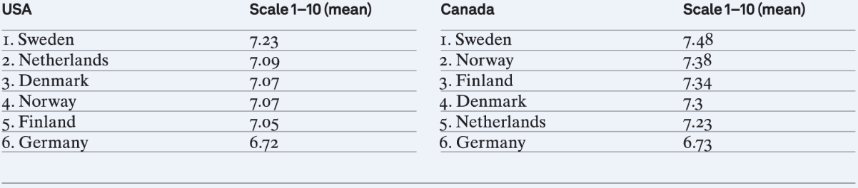

On a scale from 1 to 10, how positive or negative is your image of Sweden?

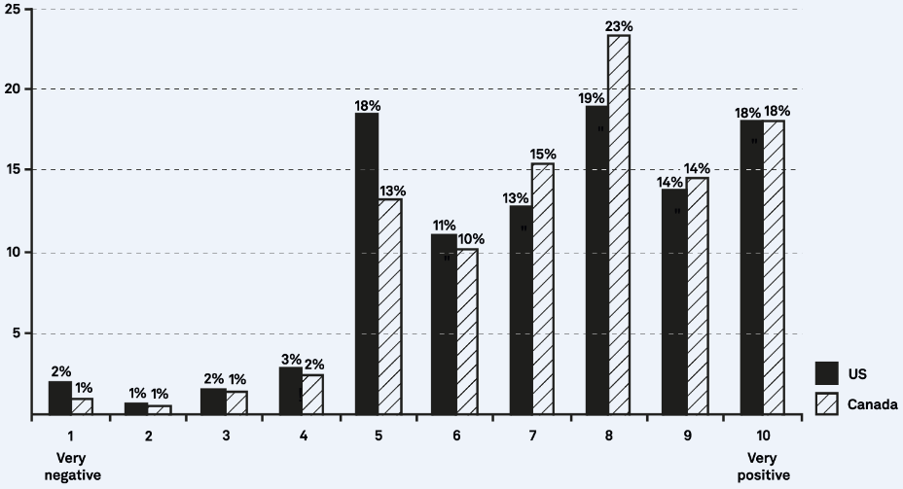

Has your image of Sweden changed over the past year:
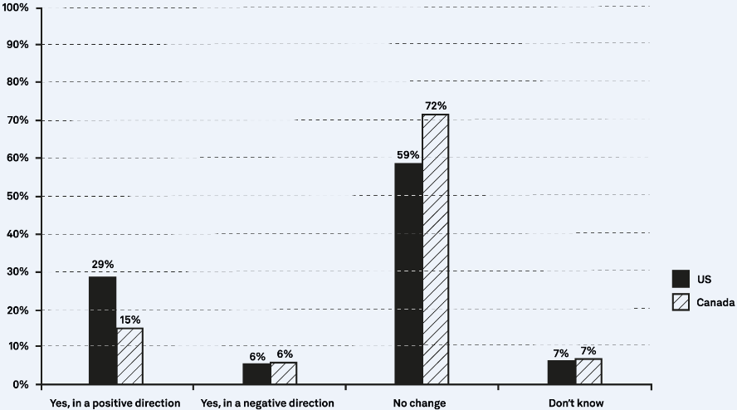

Overview of the characteristics of respondents who claim to have changed their perception of Sweden over the past year in the US:
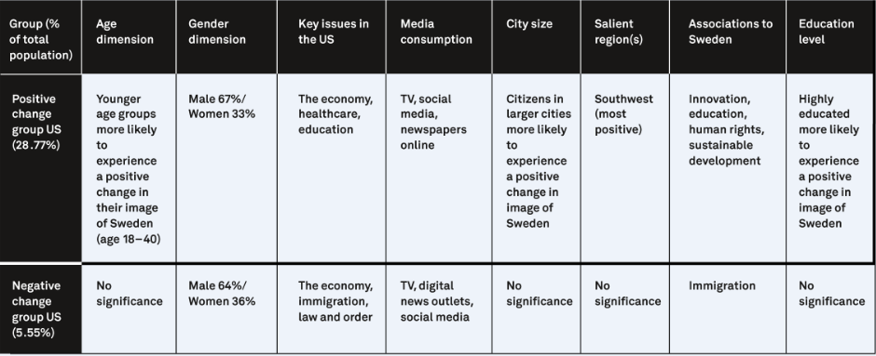

Figur 16 Översikt över de grupper som ändrat sin bild under året Kanada

Overview of the characteristics of respondents who claim to have changed their perception of Sweden in the last year in Canada:

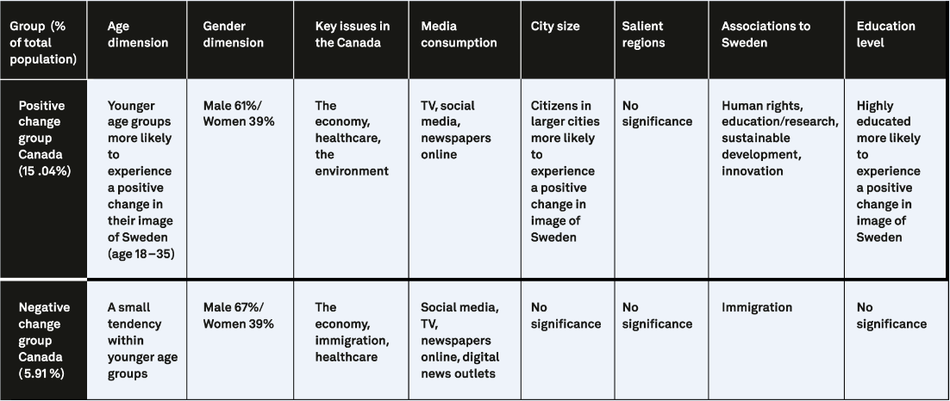

US respondents’ reasons as to why their image of Sweden has changed in a negative direction:
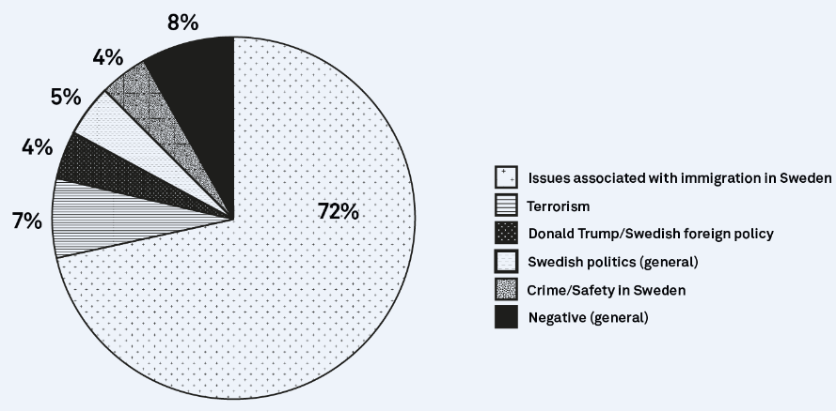

US respondents reasons as to why their image of Sweden has changed in a positive direction:

US respondents’ reasons as to why their image of Sweden has changed in a positive direction:
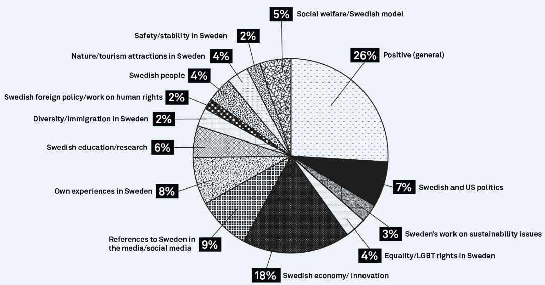

.

Canadian respondents’ reasons as to why their image of Sweden has changed in a negative direction:

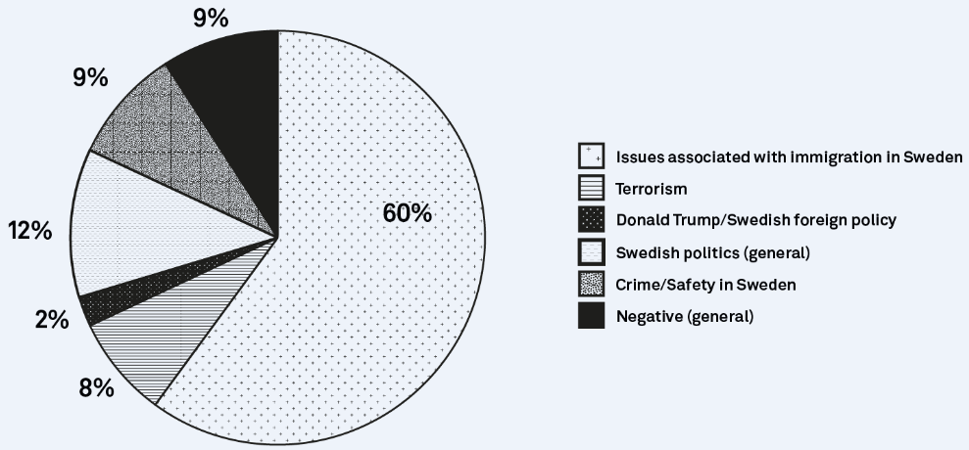

Canadian respondents reasons as to why their image of Sweden has changed in a positive direction:

US respondents’ reasons as to why their image of Sweden has changed in a positive direction:
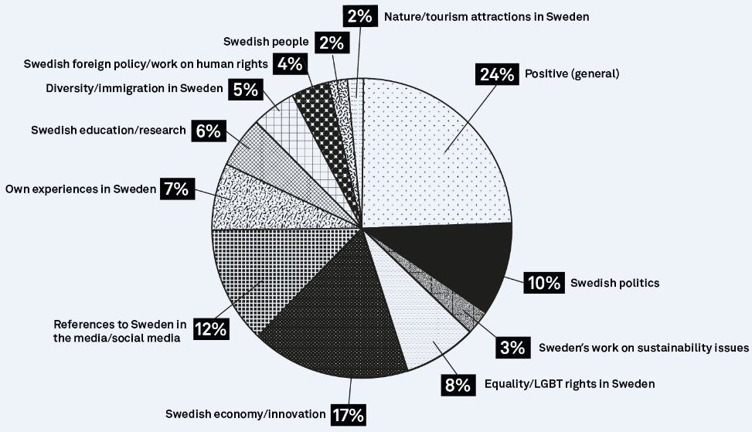

Which of the following areas or issues do you associate with Sweden:
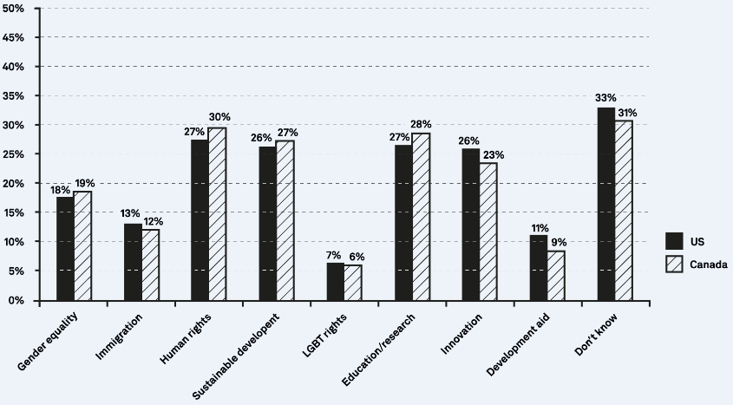

Published media articles amongst the largest US news companies since 2015 concerning migration issues in Sweden.

