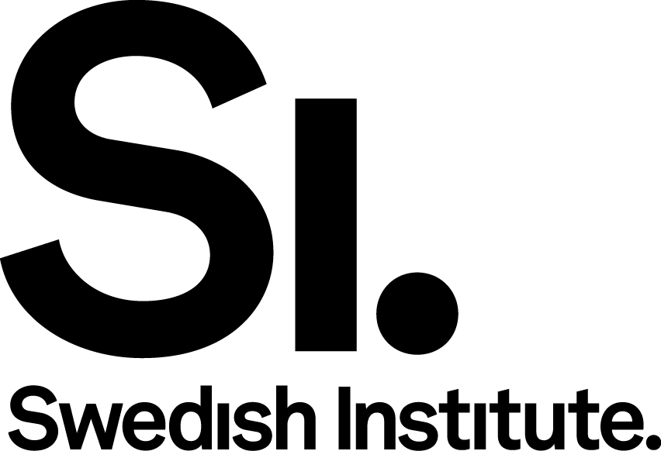

Swedish Institute Management Programme Asia
Application form 2020

Application to the Swedish Institute Management Programme (SIMP) 2020 for selected countries in Asia.

Please fill in the application form and submit it with your CV and a letter of recommendation in English (preferably using the SI template) through the SIMP Asia application portal; kindly note that we do not accept applications submitted by e-mail. More information about the application procedure is available at www.si.se/simpasia

General information

LAST NAME (FAMILY NAME) | FIRST NAME (GIVEN NAME)
DATE OF BIRTH (YEAR-MONTH-DAY) | FEMALE MALE OTHER
TOWN/CITY OF RESIDENCE | E-MAIL  SECONDARY E-MAIL
PHONE (INCLUDING COUNTRY CODE) | MOBILE PHONE (INCLUDING COUNTRY CODE)
COUNTRY OF CITIZENSHIP
CHINA
INDIA
INDONESIA
PHILIPPINES
THAILAND
VIETNAM

In the questions below, please explain your motivation for applying to the SIMP Asia 2020. Please be as specific and detailed as possible in your answers. Make sure you answer all the questions in the application. All information should be submitted in English.

Questions

1) Please describe the organisation where you work:

- The focus and mission of your organisation [400 characters maximum]
- The size and impact on the market (start-up/SME/large/multinational etc) [400 characters maximum]

2) Evaluate and describe your possibilities (e.g. role, position, mandate) to influence and develop processes and work carried out within your company/organisation. [800 characters maximum]

3) Which are some of the main challenges and opportunities that your country faces today? How can these challenges and opportunities be addressed? [1200 characters maximum].

4) Personal statement: Why do you want to attend SIMP Asia 2020? How do you hope to develop as a leader? [800 characters maximum]

5) Explain how SIMP Asia could empower you to lead your organisation towards more sustainable business practices and responsible leadership? Kindly provide a concrete example of a change you would like to see in your organisation. [800 characters maximum]

6) Please describe how you could contribute to making the programme more interesting for other participants (e.g. specific experience, tangible networks etc.). [800 characters maximum]

7) Describe how you collaborate with others in your work. Kindly give an example of how you, together with others, have overcome a challenge in a professional context [800 characters maximum]

8) Please describe your personal experience, if any, of contributing to positive, societal change. [800 characters maximum]

9) Describe your personal and/or professional goals for the coming five – ten years. [800 characters maximum]

10) Have you previously collaborated with Swedish companies/organisations? Kindly describe your collaboration. [500 characters maximum]

11) Where and how did you get information about SIMP Asia 2020? [800 characters maximum]

Reference persons:
Please provide the name, e-mail and telephone number of two reference persons who are familiar with your work with change management. We will also need a letter of recommendation from one (1) of these persons (max 1 page). We may contact the reference persons of the applicants who are selected for an interview. We can only accept references who speak English.

Web sources (not compulsory):
If available, please feel free to share a maximum of five web sources (websites, blogs, Twitter account etc.) that can give us more information about relevant work that you are involved in. The web sources can be in any language.

