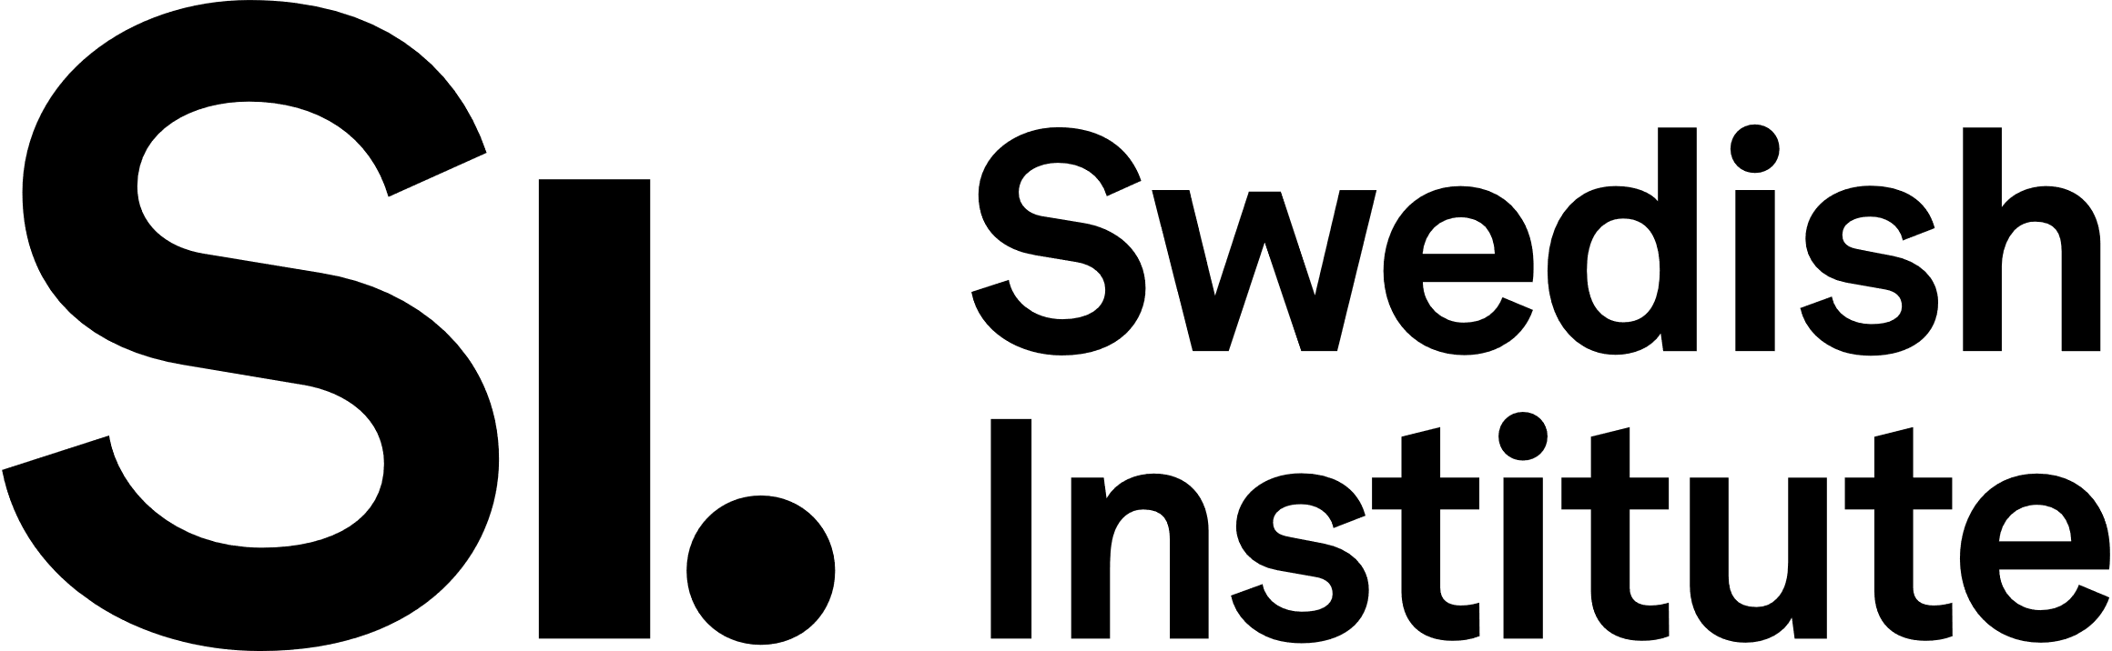 For contact details visit www.si.se
Datum: Date: 2024-06-17
Enclosure: 7
Document: Certificate of de minimis aid

SI Baltic Sea Neighbourhood Programme – Cooperation projects

Enclosure 7: Certificate of de minimis aid
Call for funding with application deadline 17 September 2024.

About this enclosure
When the Swedish main applicant for a project application to the SI Baltic Sea Neighbourhood Programme is a business company, a certificate of de minimis aid (refers to financial state support) must be enclosed to the application. This enclosure (intyg om försumbart stöd, sw. term.) should inform about other previous de minimis aid already received.

Details of the organisation and the project application

Name of organisation

Organisation Registration Number (Organisationsnummer)

Project acronym

Project title

Financial details of the company
Does the company have any kind of financial difficulties? State “Yes” or “No”

If yes, please comment:

Previous de minimis aid
Did your company during this and/or in the previous two years receive any de minimis¹ aid? State “Yes” or “No”

If yes, please indicate details in the table below:
Authority | Type of support | Amount granted², in SEK | Date of payment/transfer

¹The years referred to are the company's fiscal year. A precondition is that the company was informed by the grant provider/authority that the grant awarded and received was a de minimis aid.
²If the recieved amount was smaller than the grant awarded, the amount received should be indicated.

Authorized signatory
Full name:

Position/title:

Date and place:

Signature:

